Supervisor user guide for using ‘Turnitin for Research Students’ at De Montfort University

Accessing the Turnitin link in Blackboard
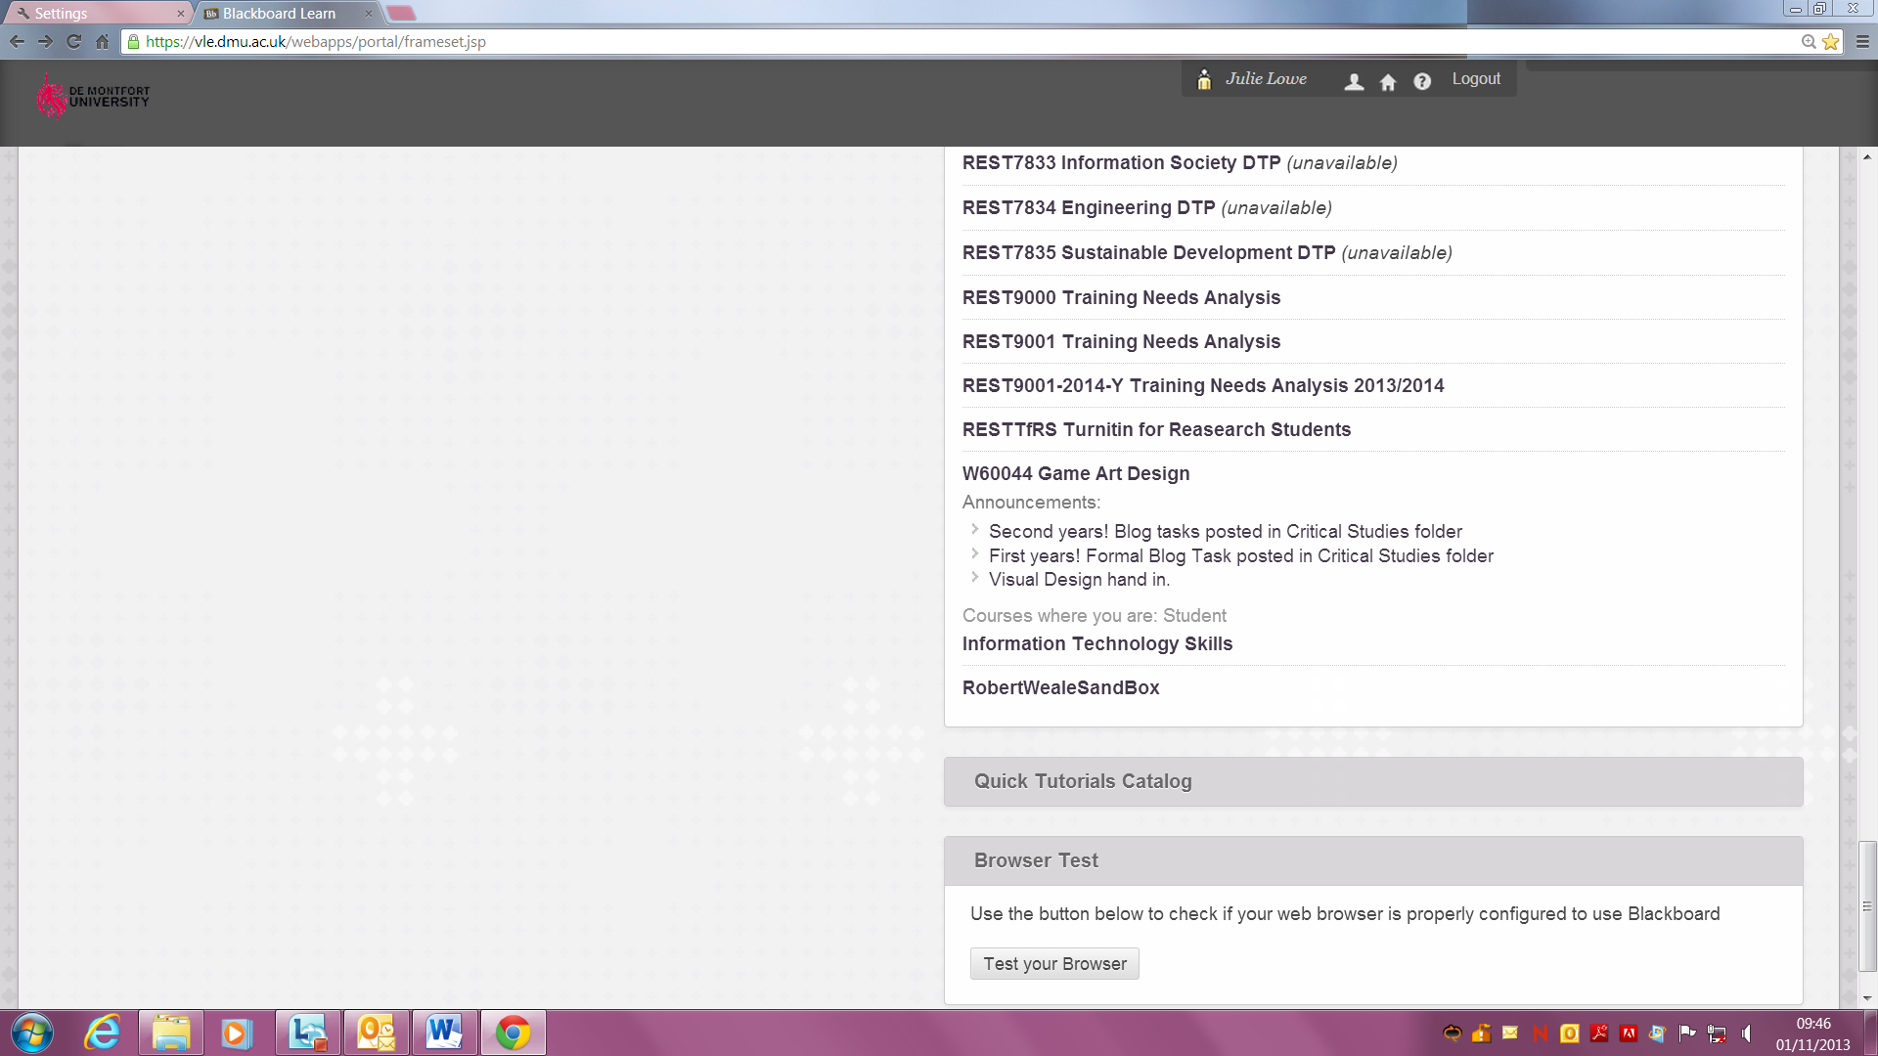
To access RESTTfRS Turnitin for Research Students go to your Blackboard home page, and locate the shell in your module list. Click on the title to open the shell.
If you do not have access to this shell please email your DMU user name to onlinetraining@dmu.ac.uk

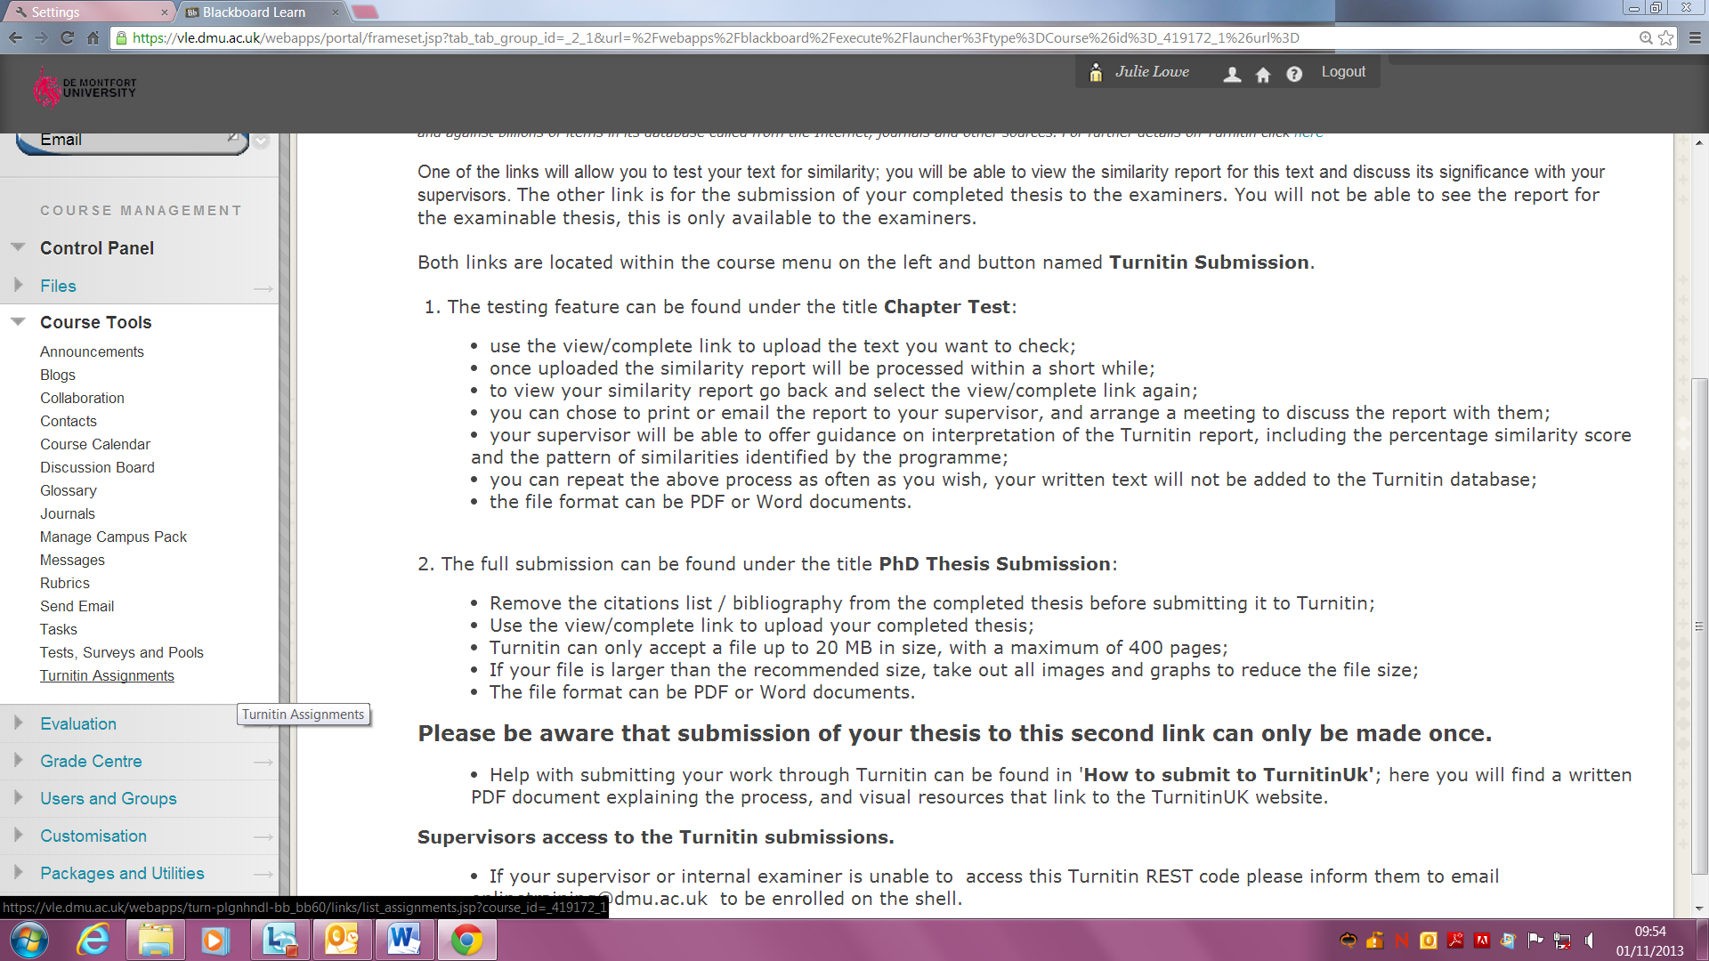
To view your research student’s report you will need to select the Turnitin assignment link.
This is located in the Course Management area of the shell, within the course tools.
Please select the Turnitin Assignments link.

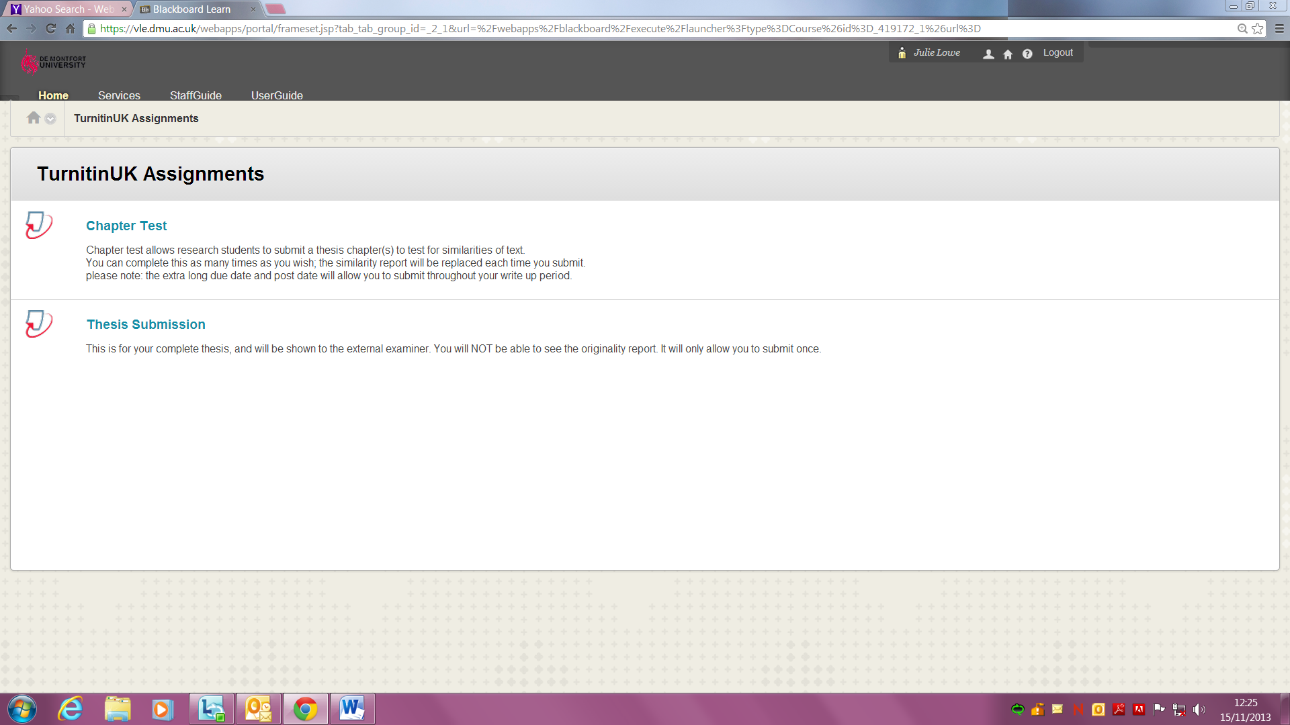
When the Assignment area is open you will see two TurnitinUK links:
Chapter Test
Thesis submission

Viewing the Chapter Similarity report
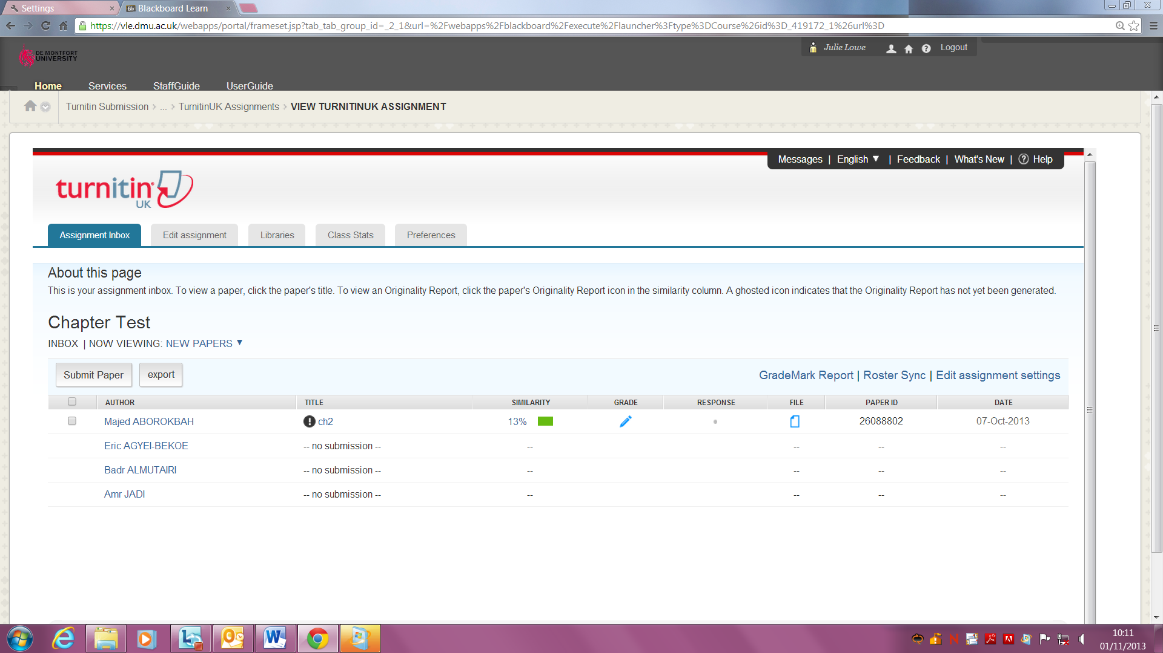
- After a student has submitted text to the Turnitin link, named Chapter Test, they and you will be able to view the Similarity report.
To locate this report:
- Select Chapter Test from the Turnitin assignment list (as above)
- Locate the student’s name via the Author column.
- Click on the column containing the similarity score next to their name. This score indicates the overall percentage of matching text from other resources.

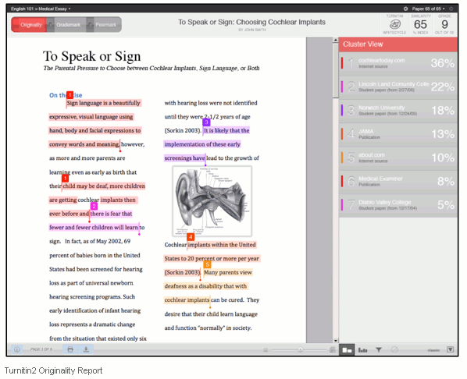
- The Similarity report will open in a new window.
Reading the report:
- Student’s text is displayed on the left, and may be displayed with coloured highlighted text.
- Coloured highlights indicate the sections of text that are identical to existing text.
- Each highlight has a number; you can cross reference this number with the list on the right to identify the source document.
- The percentage figures on the right indicate the proportion of the total document associated with each identified source.

To help your research student interpret the Turnitin report, and the meaning behind the colours, please discuss the report with them. Viewing the Similarity report will improve their writing and understanding of plagiarism and bad academic practice. Please ensure you:
- Review the report together and examine those parts of the text that have been identified as identical to other sources in terms of whether, in your view, it would be likely to be considered to constitute plagiarism or simply coincidence.
- Identify with them material that has not been correctly referenced
- If necessary, suggest your research student might benefit from courses available from the university that will improve their writing ability; more information is available online from our Library website and the Centre for Learning and Study Support (CLaSS) which provide a wide range of services and study support.
To assist you and your student in understanding the report please look at:
Turnitin website http://turnitin.com/en_us/training/instructor-training/about-originalitycheck
The CELT hub http://celt.our.dmu.ac.uk/support-using-technology/dmu-core-elt/turnitin/turnitin-staff-guide/
Students can submit their documents for checking using TurnitinUK as often as they wish. Each time a chapter is submitted a new Similarity report is created which replaces the previous one.

Interpreting the Similarity report

There is no threshold figure for the similarity score which reliably indicates evidence of plagiarism or not. In general terms, a figure below 20% is unlikely to indicate widespread plagiarism throughout the document, but even that does not discount the possibility of clear plagiarism in a small sub-section of the document. The key is to look for the distribution of coloured highlighting of the student’s text. TurnitinUK operates by identifying any sequence of 7 words within the student’s text which have previously been published on a public forum, such as on the web or in a published article. Given the volume of published material, it is not unexpected that occasionally phrases within text submitted by students will coincide with those already in the public domain. In such cases the highlighted text will consist of short sequences scattered throughout the student’s document. This is clearly linguistic coincidence and not plagiarism and students can therefore be reassured that although TurnitinUK has identified a degree of similarity between their work and published material, this would not be construed as plagiarism by an examiner.
If, however, the sequence of words highlighted in the Similarity report extends to several sentences, or worse whole paragraphs or pages, then it is highly likely that the text has been copied from another source. In such cases, the first thing to do is to check the original source and to make sure that the student is not the author of the original source (e.g. when a student has already published parts of their research). Students cannot be guilty of plagiarising their own publications and in such cases there would be no accusation of plagiarism. If, however, the original source is not the student themselves and has not been appropriately attributed in the student’s text, then it would be likely to be viewed as plagiarism by examiners. In such cases you need to discuss this with the student to determine how this might have occurred (whether by accident or design), and the importance of expressing ideas and concepts in their own words rather than relying on external sources. We are aware that there is cultural variation in the extent to which copying of source material is considered acceptable, but we must make it clear to the students that at DMU such activity will very likely be considered as plagiarism and would have very serious consequences if found in the final research degree thesis.

Viewing the full Thesis Submission Similarity report
When submitting their research degree thesis for examination, students must (from January 2014) submit an identical version of their thesis to the RESTTfRS Turnitin for Research Students as part of the examination process. Students do not have access to view the Similarity report. It is the responsibility of the Internal Examiner to check the Similarity report on the thesis submission.
To view the Similarity report for the full Thesis Submission; identify the appropriate Author or thesis Title from the TurnitinUK assignment page; and access the Similarity report by following steps 1 and 2 above.
Following the guidelines above, as Internal Examiner you must then form a judgement on whether there is evidence of plagiarism or not. If you think there may be evidence for plagiarism, please send a copy of the Similarity report (as explained below) to the Director of the Graduate School (gsd@dmu.ac.uk) and highlight your concerns.

Now that we are checking all thesis submissions by this route, it is good practice to send a copy of the Similarity report to the External examiner(s).

Revealing the report to External examiners
To save the Similarity report electronically select the print icon located at the bottom of the report screen.

Select - download PDF of current view for printing.
Please Note- when in PDF format the originality report does not have colour coding. Instead you will see numbers with corresponding footnotes of the originality source.

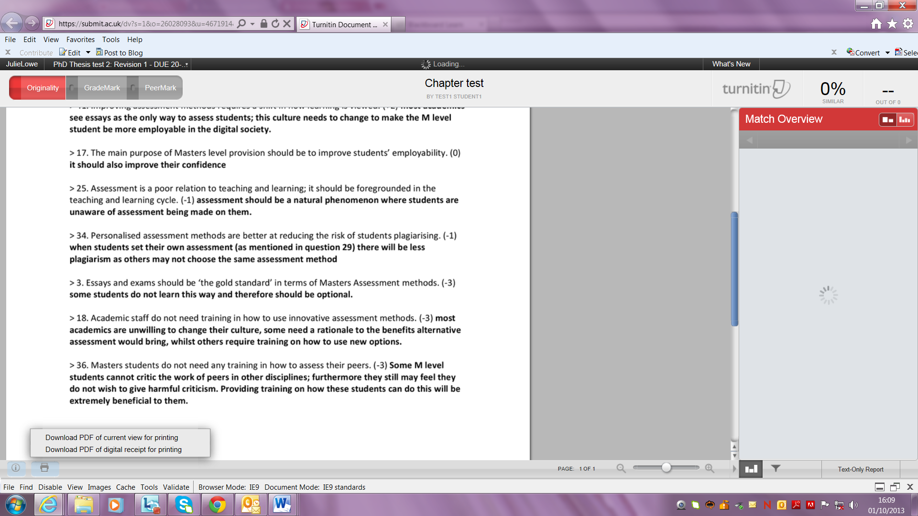

As indicated above, if you do suspect plagiarism in the student’s thesis, send a copy of the Similarity report to the Director of the Graduate School before contacting the External examiner. If your suspicion of plagiarism is confirmed then the examination process will be stopped and the Graduate School Office will advise on further action.

If you are satisfied that the thesis shows no evidence of plagiarism, either send a copy of the Similarity report to the External examiner together with your conclusion or take a copy to the viva so that the External examiner is informed of the outcome ahead of the viva examination.

