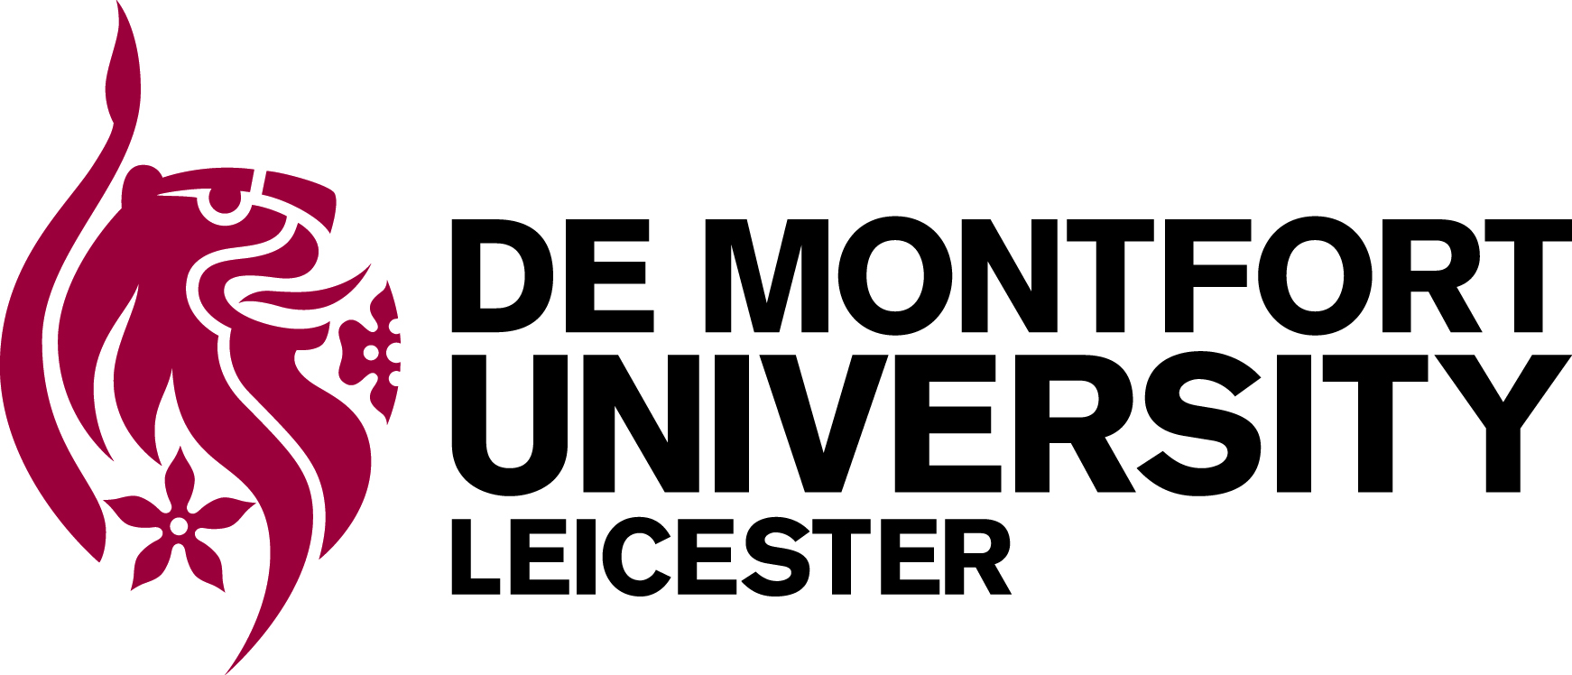

PhD Studentship

Ethical Assessment and Evaluation of Research and Innovation

Centre for Computing and Social Responsibility, Faculty of Technology, De Montfort University, Leicester

STARTING OCTOBER 2014

A PhD research studentship covering stipend and tuition fee costs is offered within the Faculty of Technology working with an internationally recognised research team. It is available to suitably qualified UK or EU students.

The project will be undertaken in the context of the EU-funded project SATORI (Stakeholders Acting Together On the ethical impact assessment of Research and Innovation). The SATORI project is a Mutual Mobilisation and Learning Action comprising 16 partner organisations from 13 countries with the aim of establishing a common European framework for ethical assessment of research and innovation. The particular focus of the DMU contribution to the project is on the internal and external evaluation of the project.

The successful candidate will be part of the DMU SATORI project team. She or he will be able to build on and link with a number of research projects in the area, such as EU projects (ETICA, www.etica-project.eu; CONSDIER, www.consider-project.eu) and UK projects (FRRIICT, www.responsible-innovation.org.uk). The PhD will link with two major projects in the area: the Human Brain Project (https://www.humanbrainproject.eu; WP12.4 “Researcher Awareness”) and the DREAM project, an EU integrated project focusing on robot-enhanced therapy for children with autism spectrum disorders.

The successful applicant will be able to work with internationally leading scholars from a range of disciplines in the underlying projects and will have the opportunity to feed results back into research and development policy and practice. The PhD project will be supervised by Professor Bernd Stahl, Professor Mark Coeckelbergh and Dr. Kutoma Wakunuma.

For more information about the studentship project please visit our web site (www.dmu.ac.uk/ccsr) or contact Professor Bernd Stahl on +44 (0)116 2078252 or email bstahl@dmu.ac.uk

This research opportunity builds on our excellent past achievements and looking forward to REF2020 and beyond. It will develop the university’s research capacity into new and evolving areas of study, enhancing DMU’s national and international research partnerships.

Applications are invited from UK or EU students with a good first degree (First, 2:1 or equivalent) in a relevant subject. Doctoral scholarships are available for up to three years full-time study starting October 2013 and provide a bursary of £13,770pa in addition to university tuition fees.

Applications should be supported by two references and guidance on these can also be found at the link above.

Please quote ref: SATORI Scholarship 2014

Late applications will not be considered

CLOSING DATE: Friday April 4th, 2014

