Center for Intercultural Research in Communication and Learning

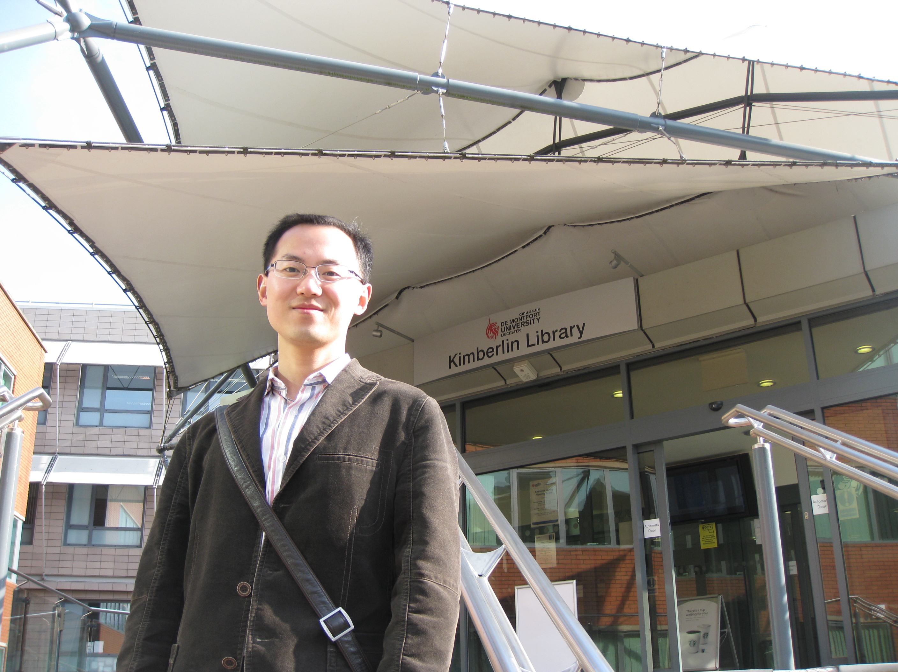

Lei Dai is a full-time PhD student in the Centre of Intercultural Research in Communication and Learning (CIRCL) at De Montfort University (DMU) on conference interpreters’ intercultural awareness with research interests in translation and intercultural studies. He obtained an MA in Applied Linguistics from Zhongnan University of Economics and Law in 2009 and BSc in Economics from Jianghan University, China in 2005.

Before studying at DMU, Lei taught English in a Chinese University for over 4 years. He has published a few academic papers and English textbooks. His conference paper On Compilation of Consecutive Interpreting Textbooks for MTI was awarded with the Third Prize in the 3rd Central and South China Symposium on Translation Studies and Translation Teaching.

Lei has attained some qualifications in translation and interpreting, such as China Accreditation Test for Translators and Interpreters (CATTI) and translator levelⅡ(professional translator), accredited by the Ministry of Human Resources and Social Security of China. Apart from teaching and researching interpreting, he provided quality translation and interpretation service for intercollegiate academic exchanges of the university he worked for. Lei has now provided translation and interpretation service for the Faculty of Health and Life Sciences at DMU while he is mainly devoting his time to his PhD research.

